Name: Date:

Word problems using all four operations – set one
I can solve problems involving addition, subtraction, multiplication and division.
Read the following problems carefully and decide on the operation/s needed to solve them. Remember to show all of your workings out and to check your answer makes sense.
- Malcolm wanted to earn some extra pocket money.

He earned £3.50 for washing the car, £5.17 for washing up, £2.86 for dog walking and £4.37 for cleaning out the kitchen cupboards.

- How much did he earn altogether?

- He wanted to buy a Lego model that cost £17.99. Did he have enough money? If not, how much more did he have to save?

- Mrs Kirk is a teacher. She has 29 children in her class. She buys a rubber for 16p and a pencil for 13p for each child. How much change does she have left from £10?

- Every Monday to Friday, Tom cycles from Backwell to Winford which is 6.3 kilometres (km) and then from Winford to Wrington which is 8.1 km and then returns to Backwell which is 8.8 km.
He also goes for a bike ride on Saturday.
By the end of the week, Tom has cycled 139.6 km.
How long was his bike ride on Saturday?

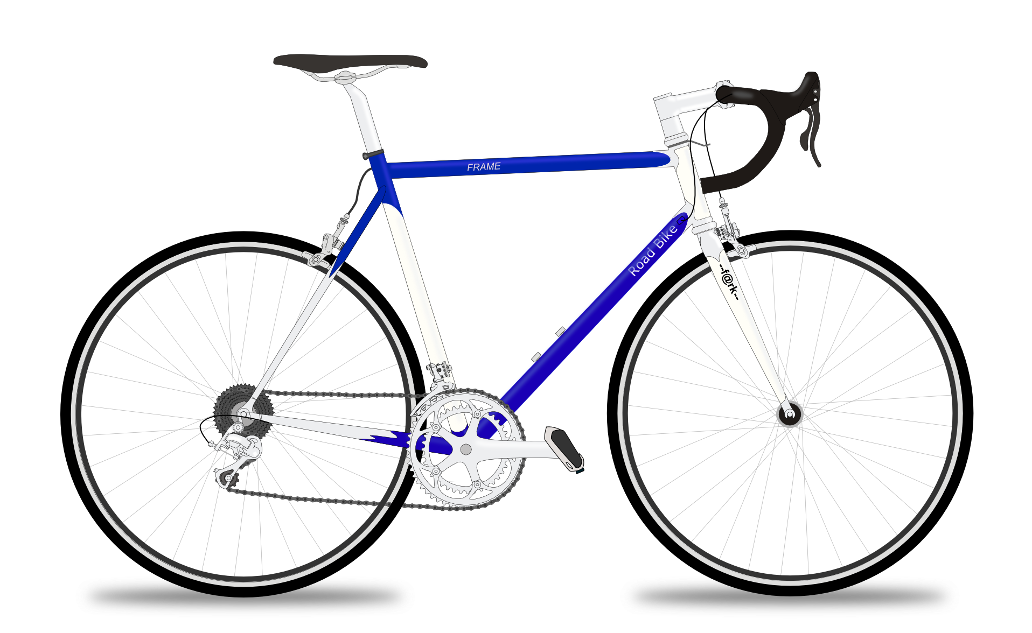
- Leanna invites seven friends to her party. Her Mum gives her a budget of £9.60 for party food.
She buys a drink costing 23p for each child.
How much money does she have left to spend on party food for each child including herself?

- Fred the zookeeper looks after the seals. He has 63 fish to share between the seven seals and 65 fish to share between the 13 penguins. Does a seal or a penguin get the most fish?

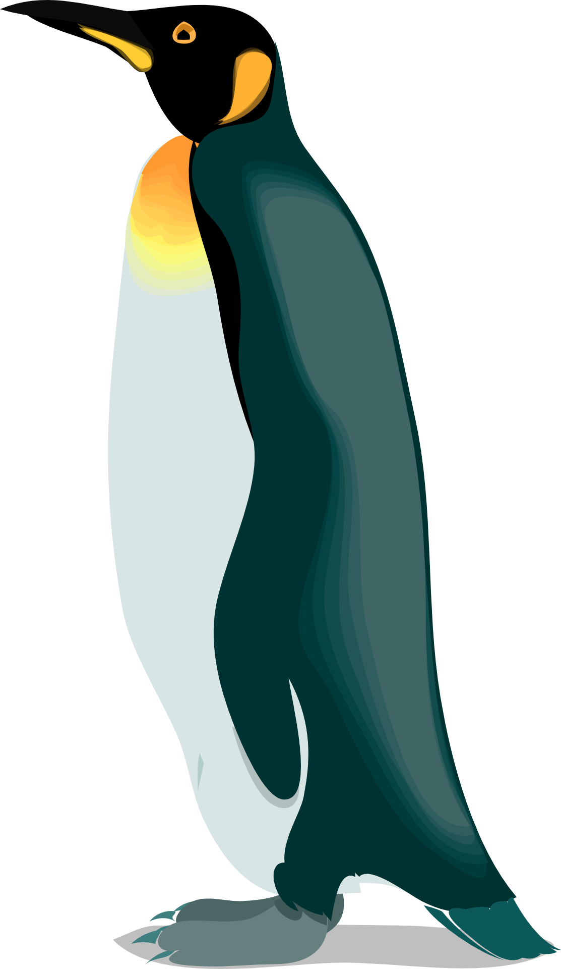

Name: Date:

Word problems using all four operations – set two

I can solve problems involving addition, subtraction, multiplication and division.

Read the following problems carefully and decide on the operation/s needed to solve them. Remember to show all of your workings out and to check your answer makes sense.

- Malcolm wanted to earn some extra pocket money. He got £3.50 for washing the car. £5.17 for doing the washing up for a week. £2.86 for some dog walking and £4.37 for cleaning out the kitchen cupboards. How much did he earn altogether? He wanted to buy a lego model that cost £17.99. Did he have enough money? If not, how much more did he have to save?

- How much money did he earn?

- Did he earn at least £17.99?

- If he bought the model for £17.99 how much change would he have or if he didn’t have enough money how much more would he need?

- Mrs Kirk is a teacher. She has 29 children in her class. She buys a rubber for 16p and a pencil for 13p for each child. How much change does she have left from £10?
- How much money did she spend on each child?

- How much money did she spend altogether?

- How much change did she have left from £10?

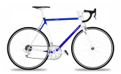
- Tom cycles from Backwell to Winford which is 6.3 kilometres and then from Winford to Wrington which is 8.1 kilometres (km) and then returns to Backwell which is 8.8 km. He does this Monday to Friday. He also goes for a bike ride on Saturday. By the end of the week he has cycled 139.6 km. How long was his bike ride on Saturday?

- How far did Tom cycle each week day?

- How far did Tom cycle in total from Monday to Friday?

- How long was Saturday’s bike ride?

- Lianna invites seven friends to her party. Her Mum gives her a budget of £9.60 for party food. She buys a drink costing 23p for each child. How much money does she have left to spend on party food for each child including herself?

- What was Leanna’s budget for each child?

- How much did Leanna have to spend on each child after she had bought the drinks?

- Fred the zoo keeper looks after the seals. He has 63 fish to share between the seven seals and 65 fish to share between the 13 penguins. Does a seal or a penguin get the most fish?

- How many fish did each seal have?

- How many fish did each penguin have?

- Did seals or penguins have the most fish each?

Word problems using all four operations – set one: Answers

- £3.50 + £5.17 + £2.86 + £4.37 = £15.90
- £17.99 - £15.90 = £2.09. He earned £15.90 so he needed another £2.09

16p + 13p = 29p
29p x 29 = £8.41
£10 - £8.41 - £1.59
She had £1.59 left.

6.3 km + 8.1 km + 8.8 km = 23.2 km
23.2 km x 5 = 116 km
139.6 km – 116 km = 23.6 km
The Saturday bike ride was 23.6 km long

£9.60 divided by 8 = £1.20
£1.20 – £0.23 = £0.97
Leanna had 97p left to spend on each child.

63 divided by 7 = 9
65 divided by 13 = 5
The seals had the most fish each.

Word problems using all four operations – set two: Answers

- £3.50 + £5.17 + £2.86 + £4.37 = £15.90
- No he didn’t.
- He needed to save more. £17.99 - £15.90 = £2.09.

- 16p + 13p = 29p
- 29p x 29 = £8.41
- £10 - £8.41 - £1.59

- 6.3 km + 8.1 km + 8.8 km = 23.2 km
- 23.2 km x 5 = 116 km
- 139.6 km – 116 km = 23.6 km

- £9.60 divided by 8 = £1.20
- £1.20 – £0.23 = £0.97
Leanna had 97p left to spend on each child.

- 63 divided by 7 = 9
- 65 divided by 13 = 5
- The seals had the most fish each.

